1) Enable cloudtrail monitoring and store the events in s3 and cloudwatch log events.

2) Enable SNS for cloudtrial to send alert on email.

3) Configure cloud watch monitoring and record the cpu utilization and other metrics of ec2.

4) Create one alarm to send alert to email if the cpu utilization is more than 70 percent.

5) Create Dashboard and monitor tomcat service wether it is running or not and send the alert.

6) Create Dashboard and monitor nginx service to send the alert if nginx is not running.

**1) Enable cloudtrail monitoring and store the events in s3 and cloudwatch log events.**

1. **Create trail from cloud trail**
2. **Select new s3 bucket, enable log validation, SNS Notification, select SNS topic and new cloudwatch.**
3. **Go to SNS service create topic creat subscriptions select Protocol as mail and give mail id and create.**
4. **Check mail and confirm then SNS created.**
5. **Now came to CT tab and select SNS existing wich is created by us.**
6. **Disable Log file SSE-KMS encryption.**
7. **Select any one or select Management events.**
8. **Create trail.**

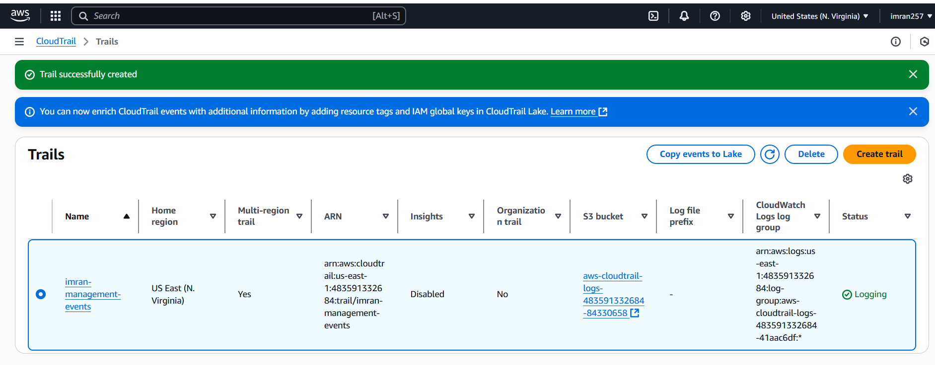

**I created instance and logs captured in S3 bucket and cloud watch log group.**

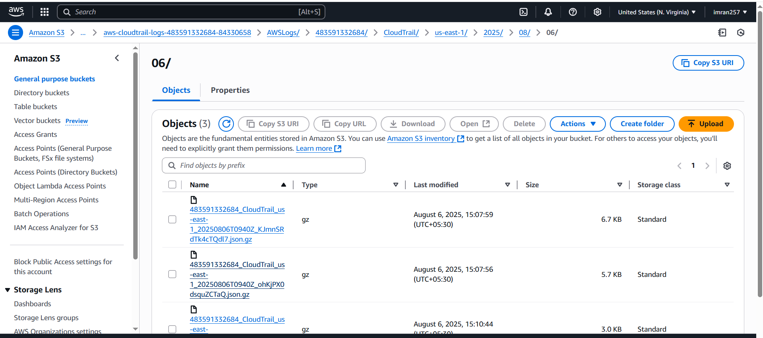

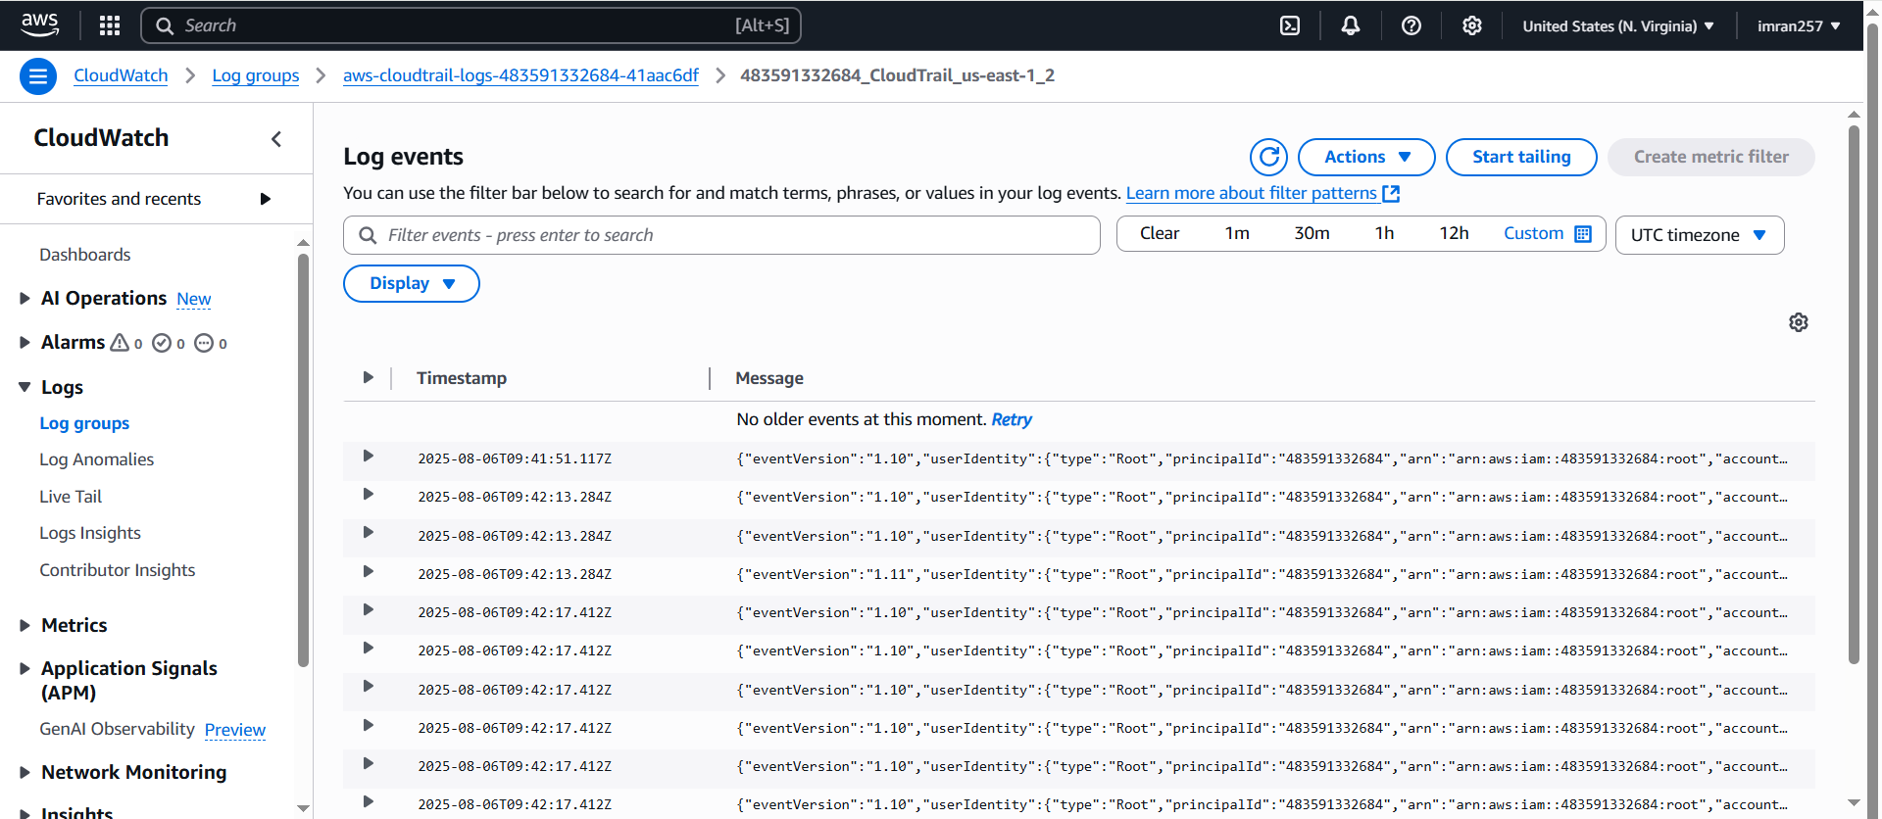

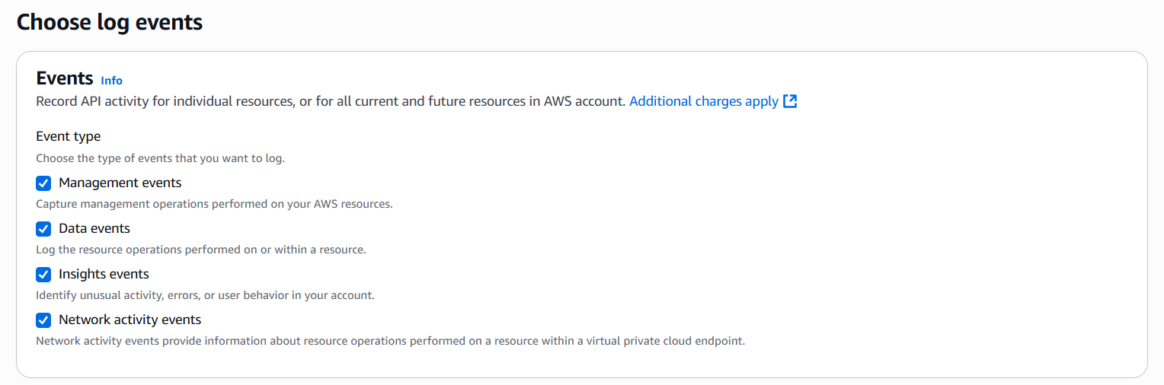

**2) Enable SNS for cloudtrial to send alert on email.**

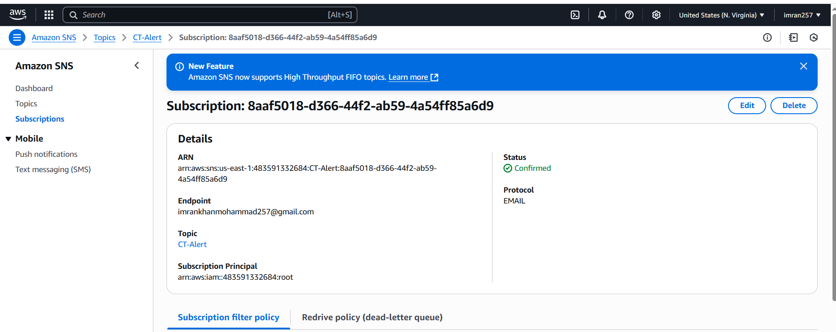

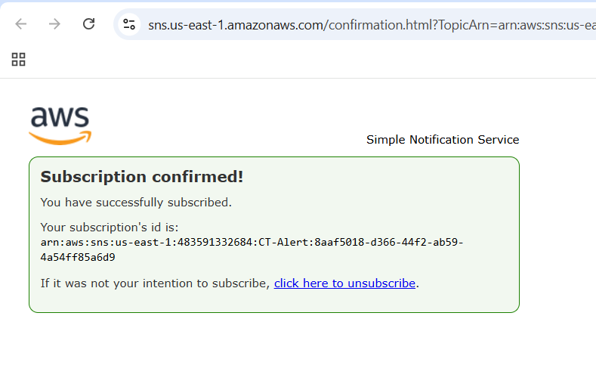

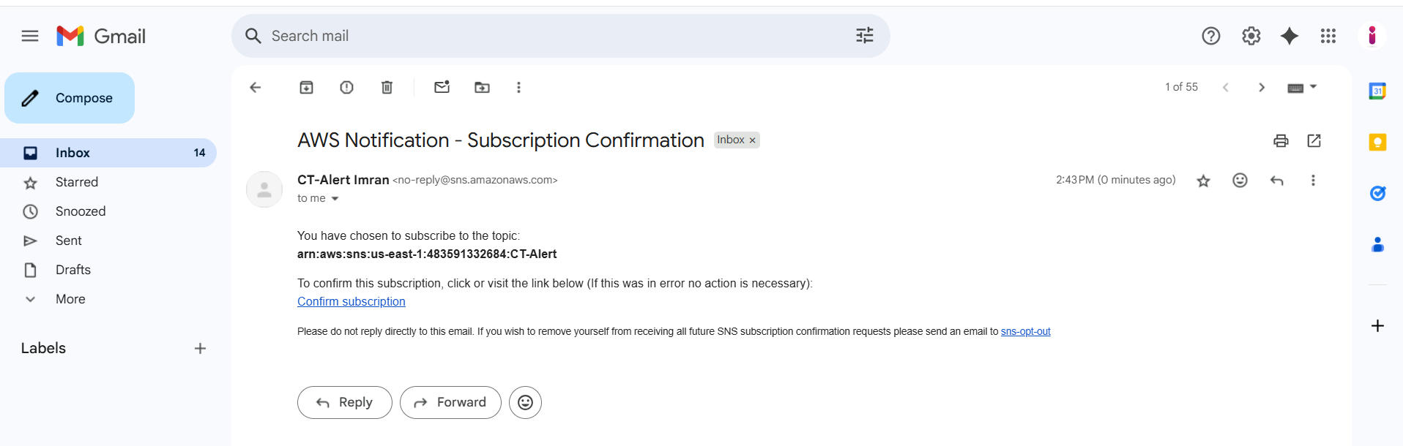

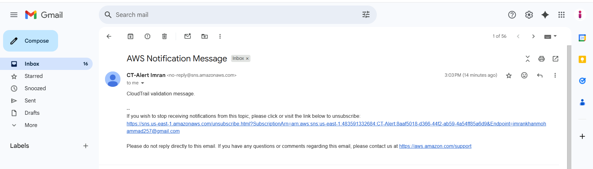

**3) Configure cloud watch monitoring and record the cpu utilization and other metrics of ec2.**

**Fake stress or load for CPU.**

**Yum install stress -y**

**Ex: stress --cpu 2 --timeout 60**

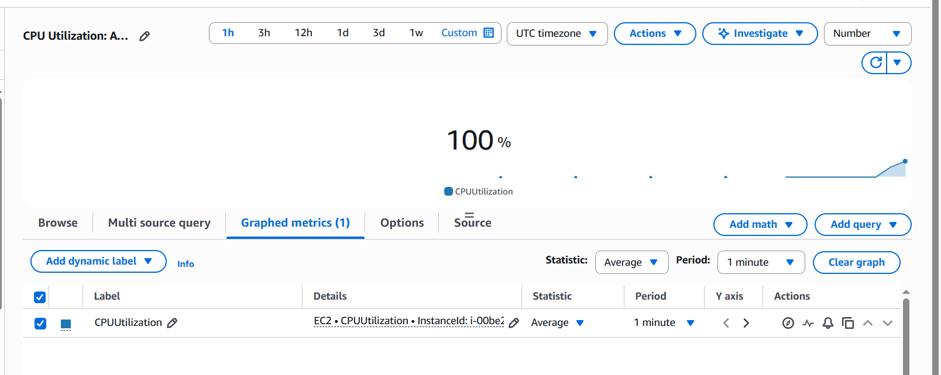

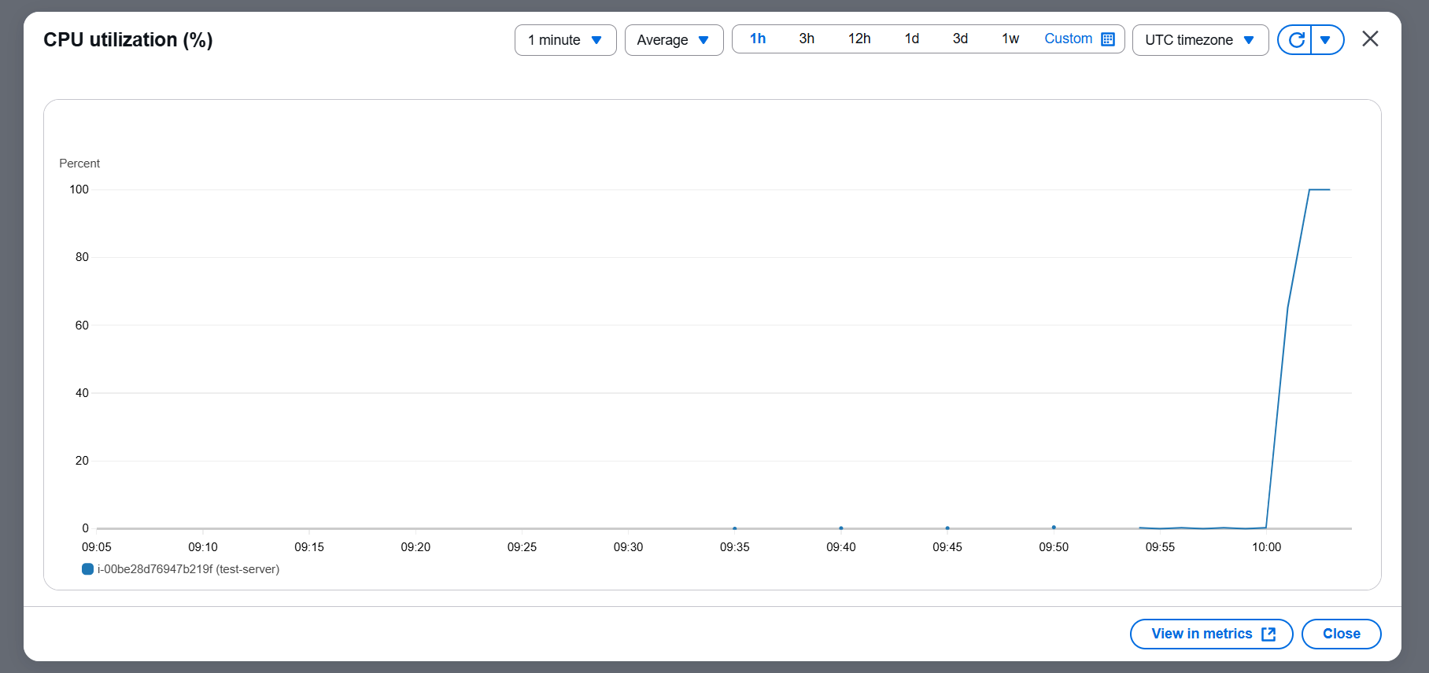

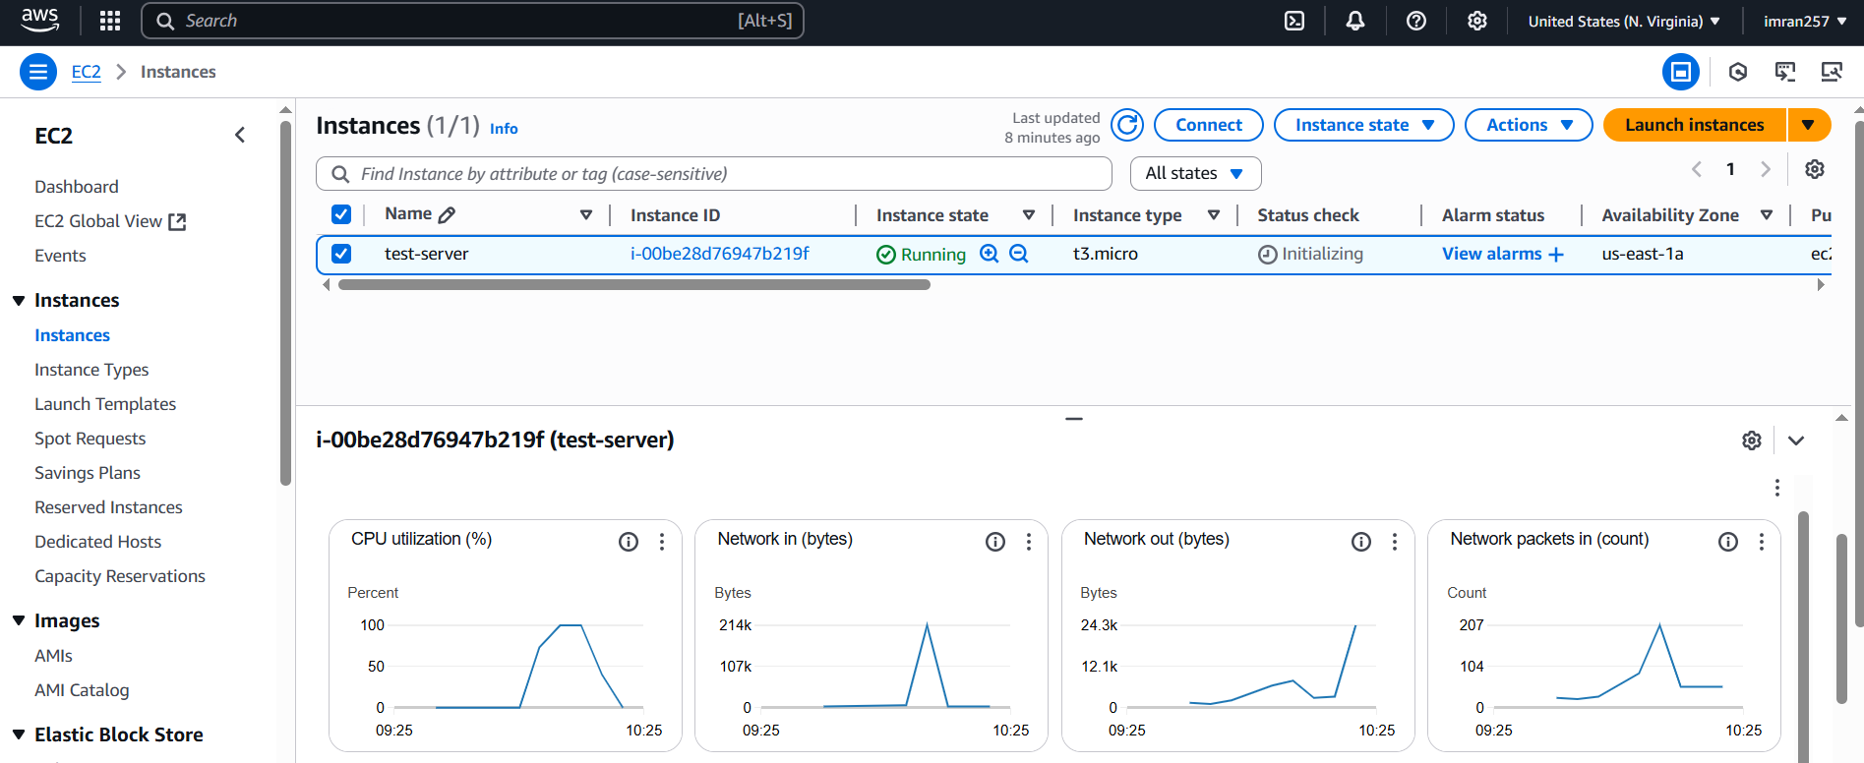

**4) Create one alarm to send alert to email if the cpu utilization is more than 70 percent.**

1. **In cloud watch create dashboard copy your instance id and select cpu utilization and select widget with number.**

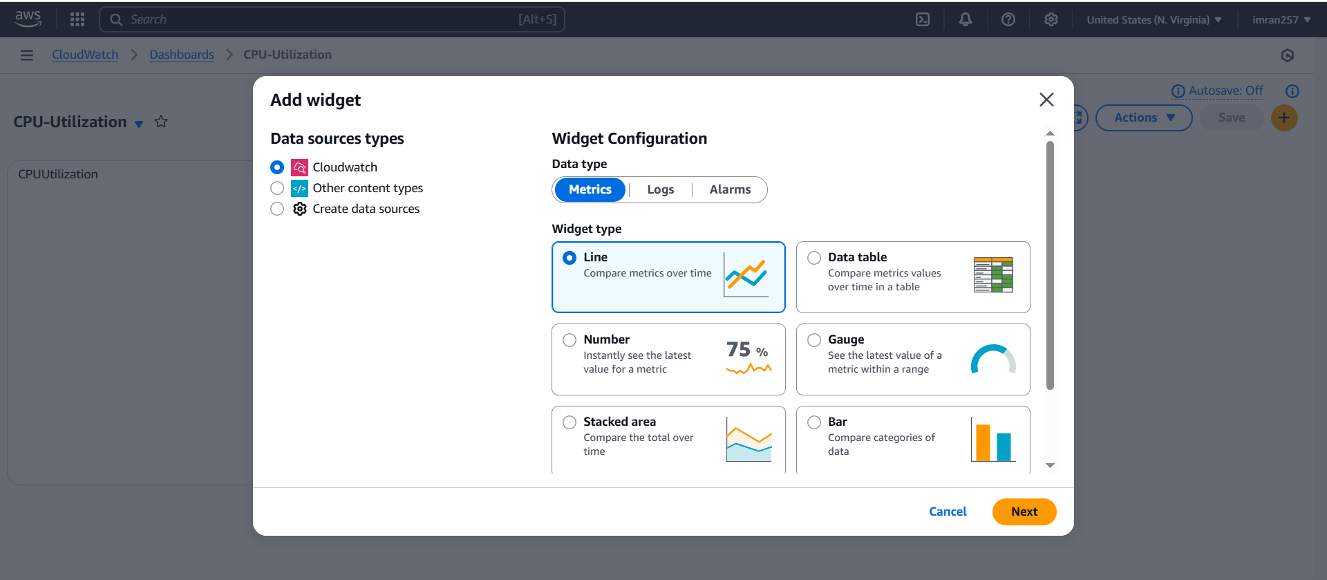

1. **Now create alarm cloud watch alarm → select your ec2 id → select metric and select datapoint 1 → condition static → select SNS (if not then create) → create**

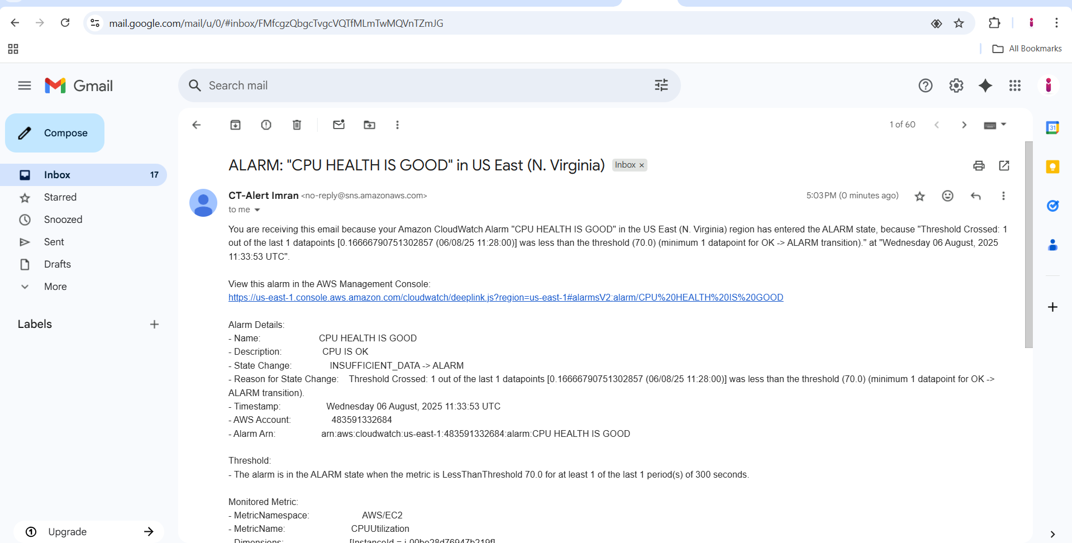

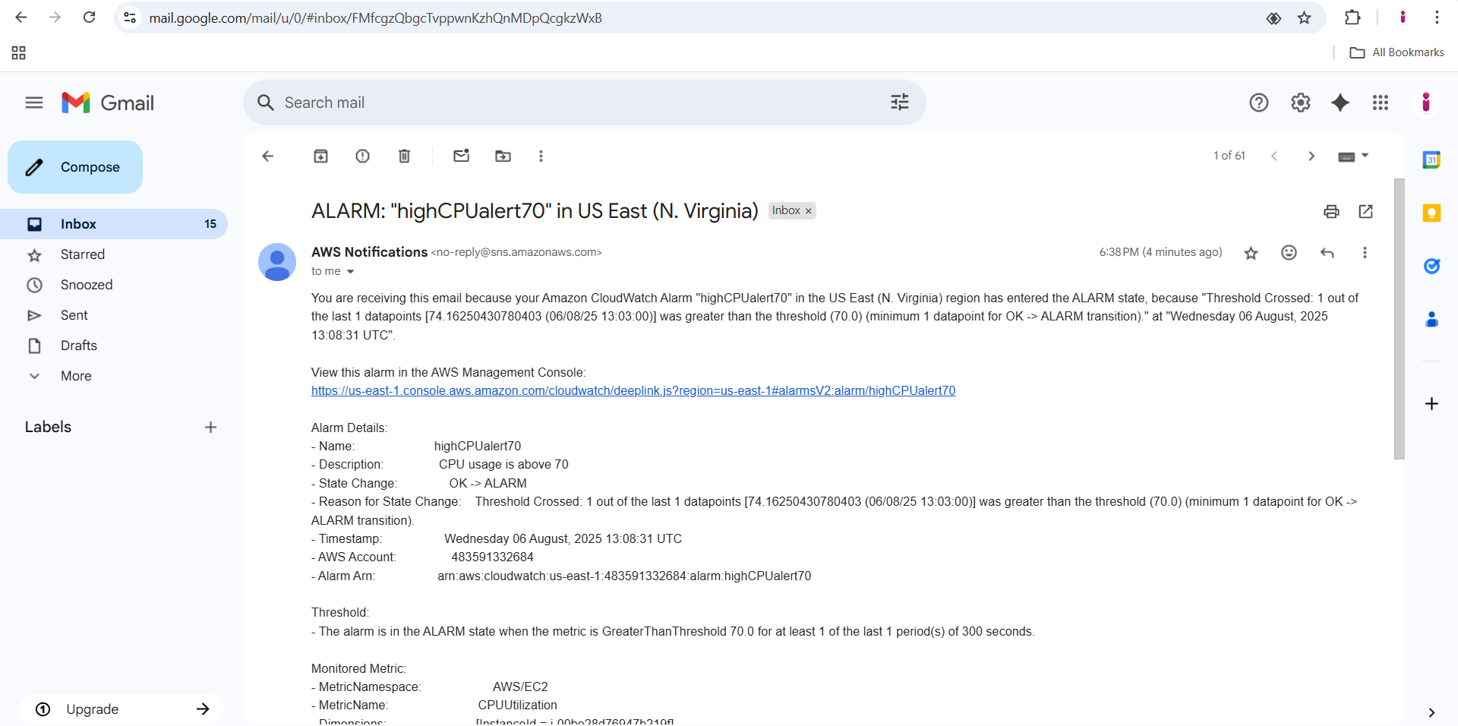

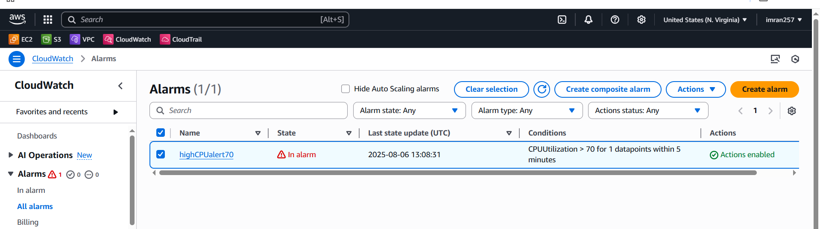

**5) Create Dashboard and monitor tomcat service wether it is running or not and send the alert.**

1. **In ec2 installed java and then apache 9.0.107 and create the script → chmod 777 → and run**
2. **Sudo wget** [**https://dlcdn.apache.org/tomcat/tomcat-9/v9.0.107/bin/apache-tomcat-9.0.107.tar.gz**](https://dlcdn.apache.org/tomcat/tomcat-9/v9.0.107/bin/apache-tomcat-9.0.107.tar.gz)
3. **sudo tar -xzf** [**apache-tomcat-9.0.107.tar.gz**](http://apache-tomcat-9.0.107.tar.gz)
4. **sudo mv apache-tomcat-9.0.107 /opt/tomcat9**
5. **cd /opt/tomcat9/bin**
6. **sudo chmod +x *.sh**
7. **[root@ip-172-31-44-227 ~]# vi monitoring.bash**
8. **[root@ip-172-31-44-227 ~]# vi monitoring.bash**
9. **[root@ip-172-31-44-227 ~]# chmod 777 monitoring.bash**

**### script taken**

**#!/bin/bash**

**# Get instance ID from metadata (v2)**

**TOKEN=$(curl -sX PUT "http://169.254.169.254/latest/api/token" \**

**-H "X-aws-ec2-metadata-token-ttl-seconds: 21600")**

**INSTANCE_ID=$(curl -s -H "X-aws-ec2-metadata-token: $TOKEN" \**

**http://169.254.169.254/latest/meta-data/instance-id)**

**# Check if Tomcat is running**

**checkTomcatStatus() {**

**pgrep -f tomcat > /dev/null**

**if [ $? -eq 0 ]; then**

**echo 1**

**else**

**echo 0**

**fi**

**}**

**i=$(checkTomcatStatus)**

**# Push to CloudWatch**

**aws --region us-east-1 cloudwatch put-metric-data \**

**--metric-name tomcat \**

**--value "$i" \**

**--namespace tomcat \**

**--dimensions InstanceId="$INSTANCE_ID"**

**Now create script in crontab**

1. **Crontab -e**

**\* * * * * /root/monitoring.bash**

1. **Once you run the monitoring.bash it will reflect in CloudWatch Dashboard.**
2. **Now create Dashboard for Tomcat you can see the tomcat select metric in number and then if metric >=1 tomcat running <=0 tomcat nor running then select SNS Topic(if not there then create) → give alarm name and done.**
3. **Now you can see in dashboard if we start the service then 1 showing , if stop service 0 showing and accordingly ALARM mail will be sent.**

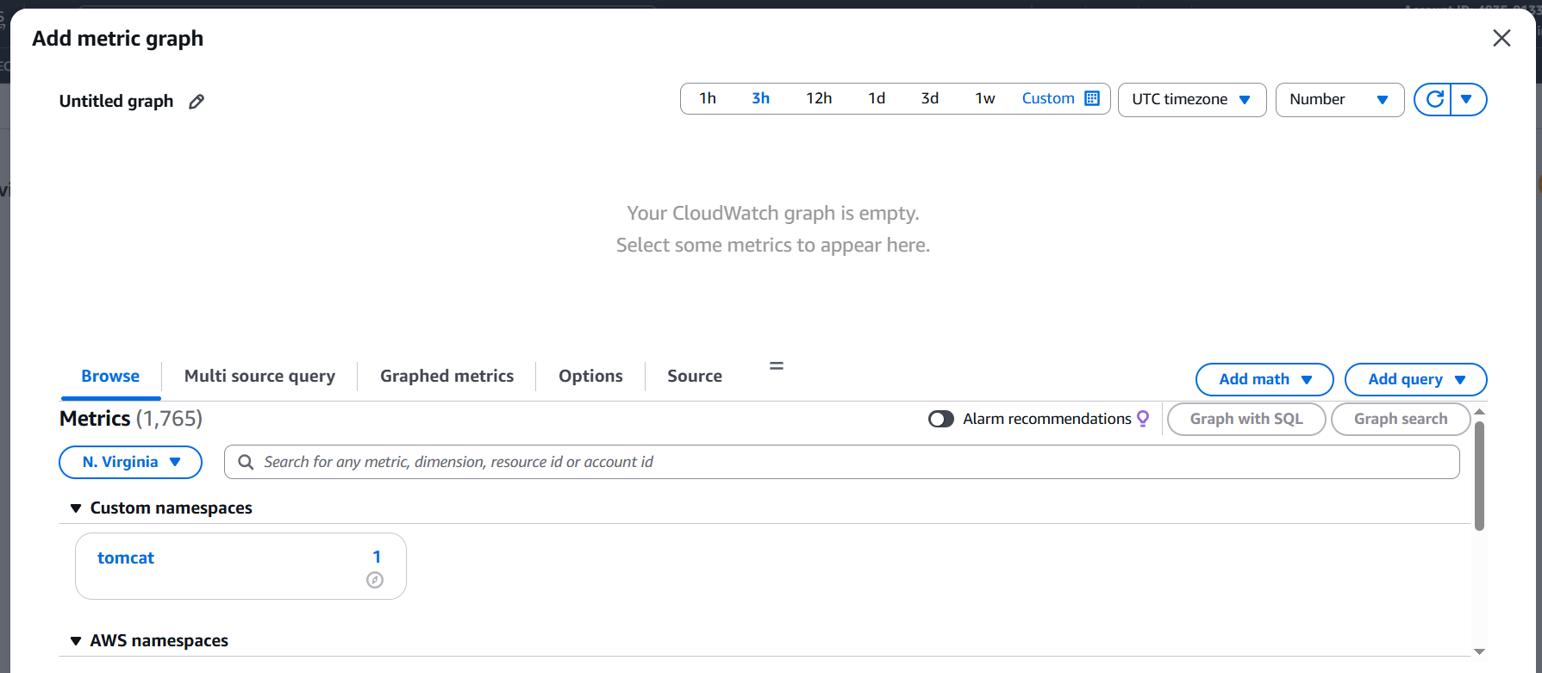

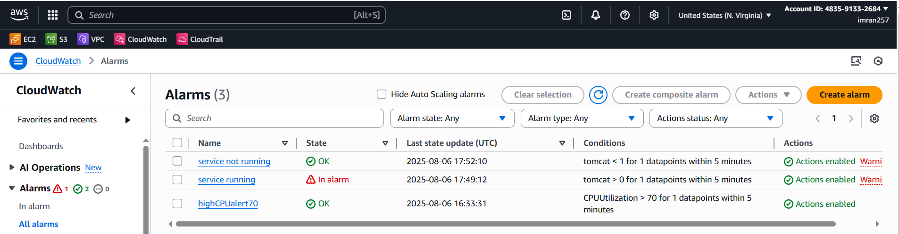

**TOMCAT RUNNING**

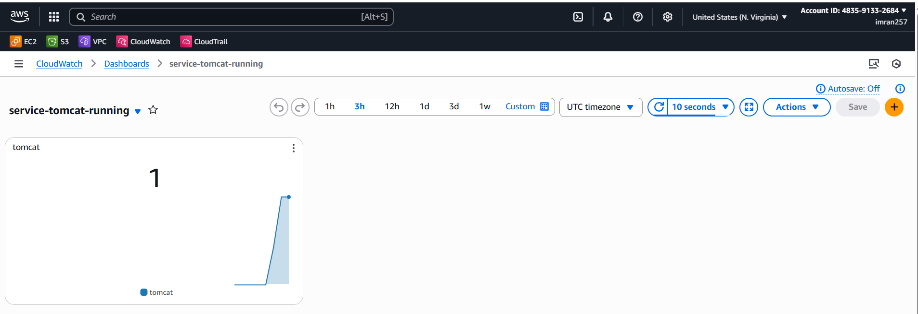

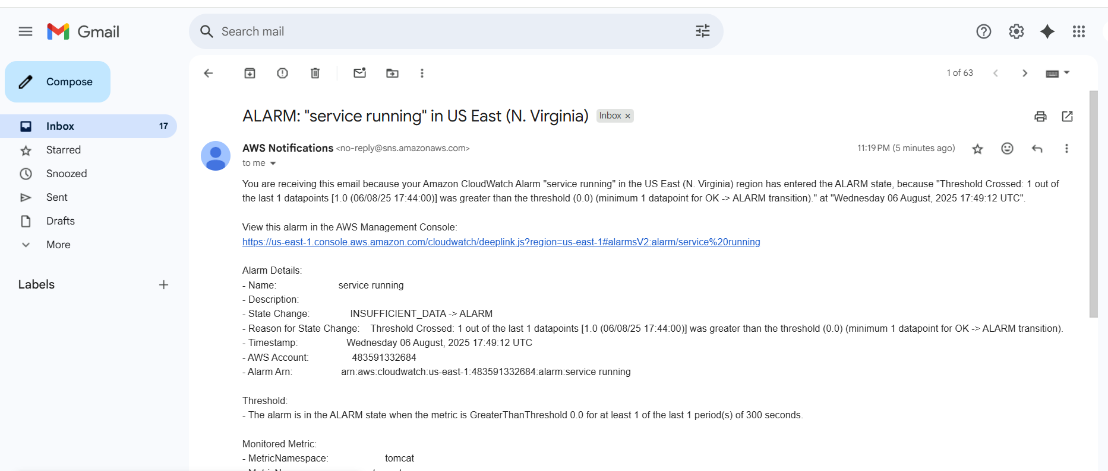

**TOMCAT NOT RUNNING**

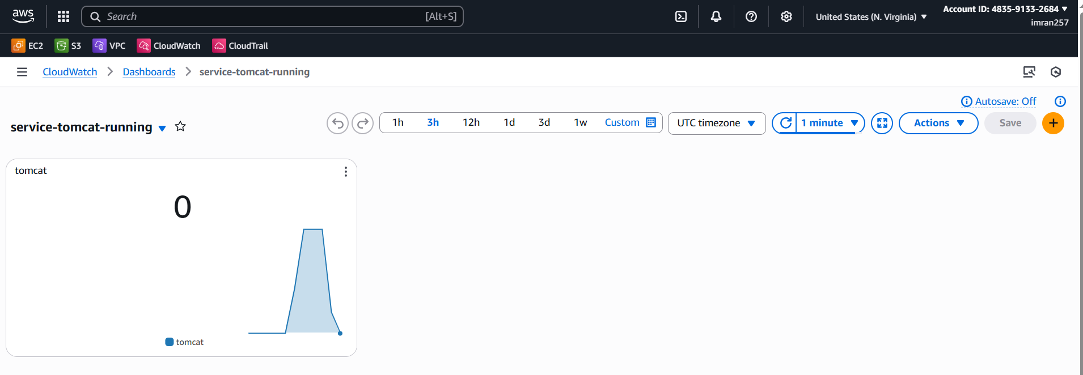

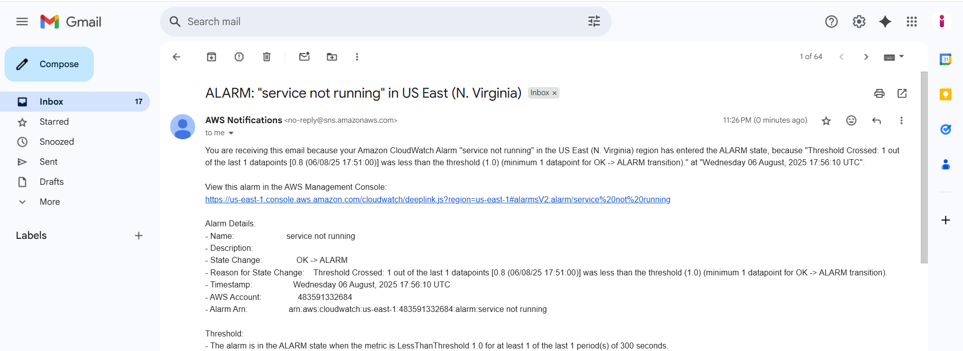

**6) Create Dashboard and monitor nginx service to send the alert if nginx is not running.**

1. **Create EC2, install NGINX and give chmod and write script save monitor.bash and give chmod x ./monitor.bash**

**And write crontab -e**

**\* * * * * /root/monitor.bash**

**And run ./monitor.bash**

**#!/bin/bash**

**REGION="us-east-1"**

**METRIC_NAME="NginxRunning"**

**NAMESPACE="Custom/Nginx"**

**/bin/systemctl is-active --quiet nginx**

**STATUS=$?**

**if [ "$STATUS" -eq 0 ]; then**

**VALUE=1**

**else**

**VALUE=0**

**fi**

**/usr/bin/aws cloudwatch put-metric-data \**

**--metric-name "$METRIC_NAME" \**

**--namespace "$NAMESPACE" \**

**--value "$VALUE" \**

**--region "$REGION"**

1. **Cloud Watch → dashboard → create dashboard → you can see service of nginx select otherwise , enter instance and check → select nginx with metric number and save.**

